***Introduction***

This is a pdf file that will briefly and precisely go over all the aspects of the assignment that needs attention.

The document has but is not limited:

1. Copies of all the wireframes
2. A copy of the link to the web application
3. A conclusion

***Wireframes***

Application

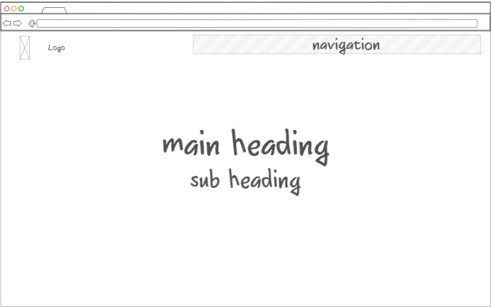

Home page

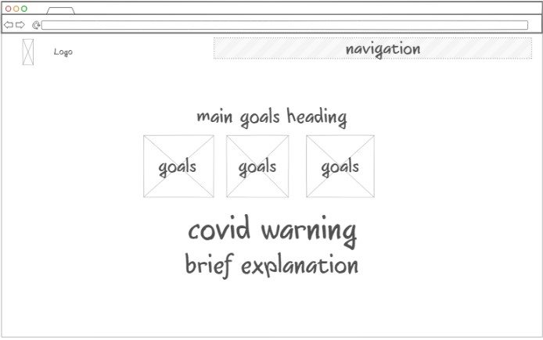

Activities

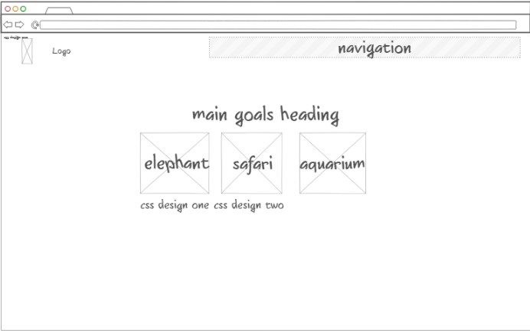

Plants and animals page

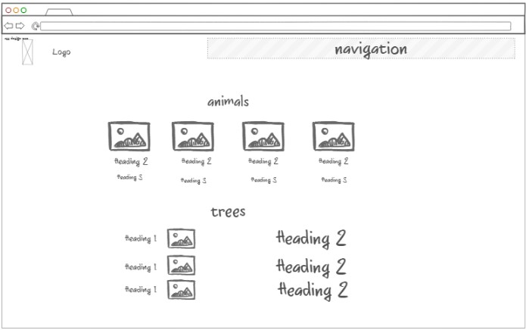

Contact us page

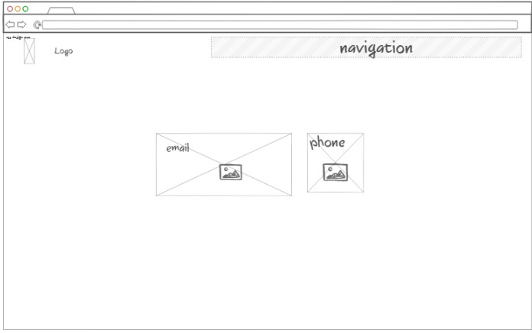

2 types of activities pages from with different styling

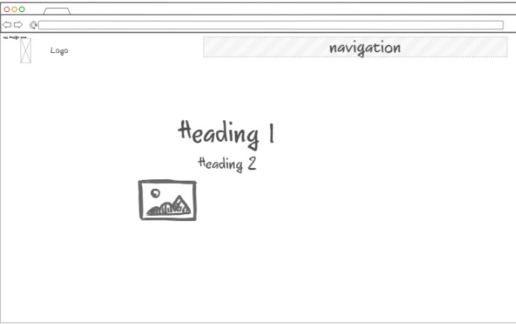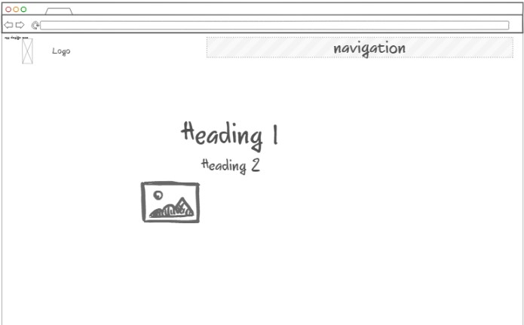

***Conclusion***

Overall, the assignment had more that sufficient time and all the necessary knowledge. Doing the assignment sure gave a very good experience of the process of making a website and the many ways of achieving a certain goal. Furthermore, calling this assignment easy would be a underestimation as it was reasonable challenging despite all the time. I am looking forward for more assignments of this type in the future as its very knowledgeable and challenging .